**Sheet 8**



Abishek Kumar



Ravikant Tyagi

Erce Can Balcioglu



8.1

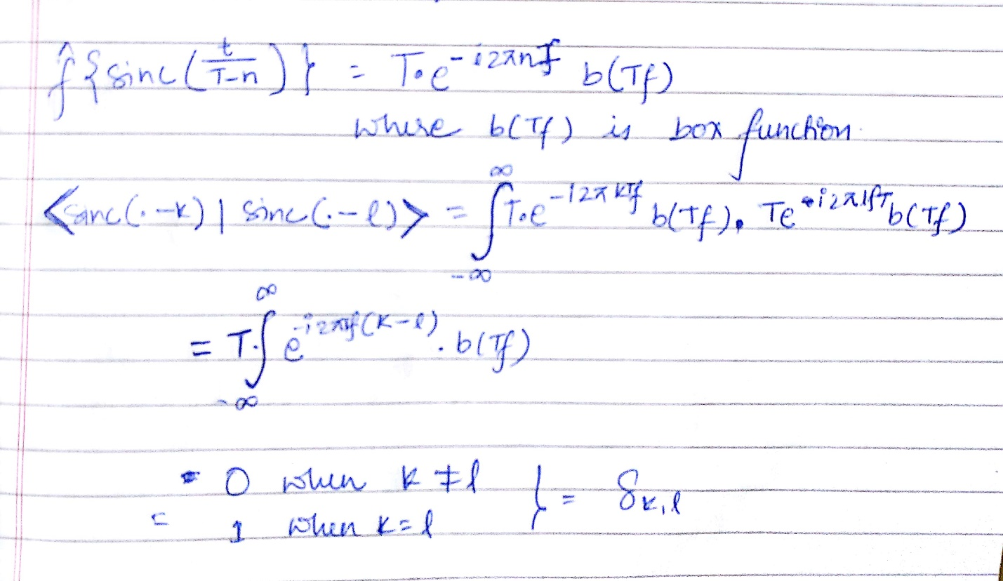



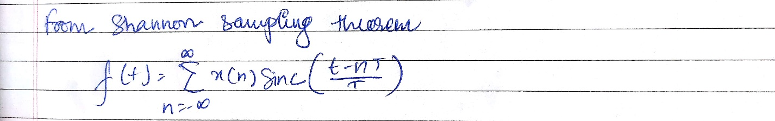

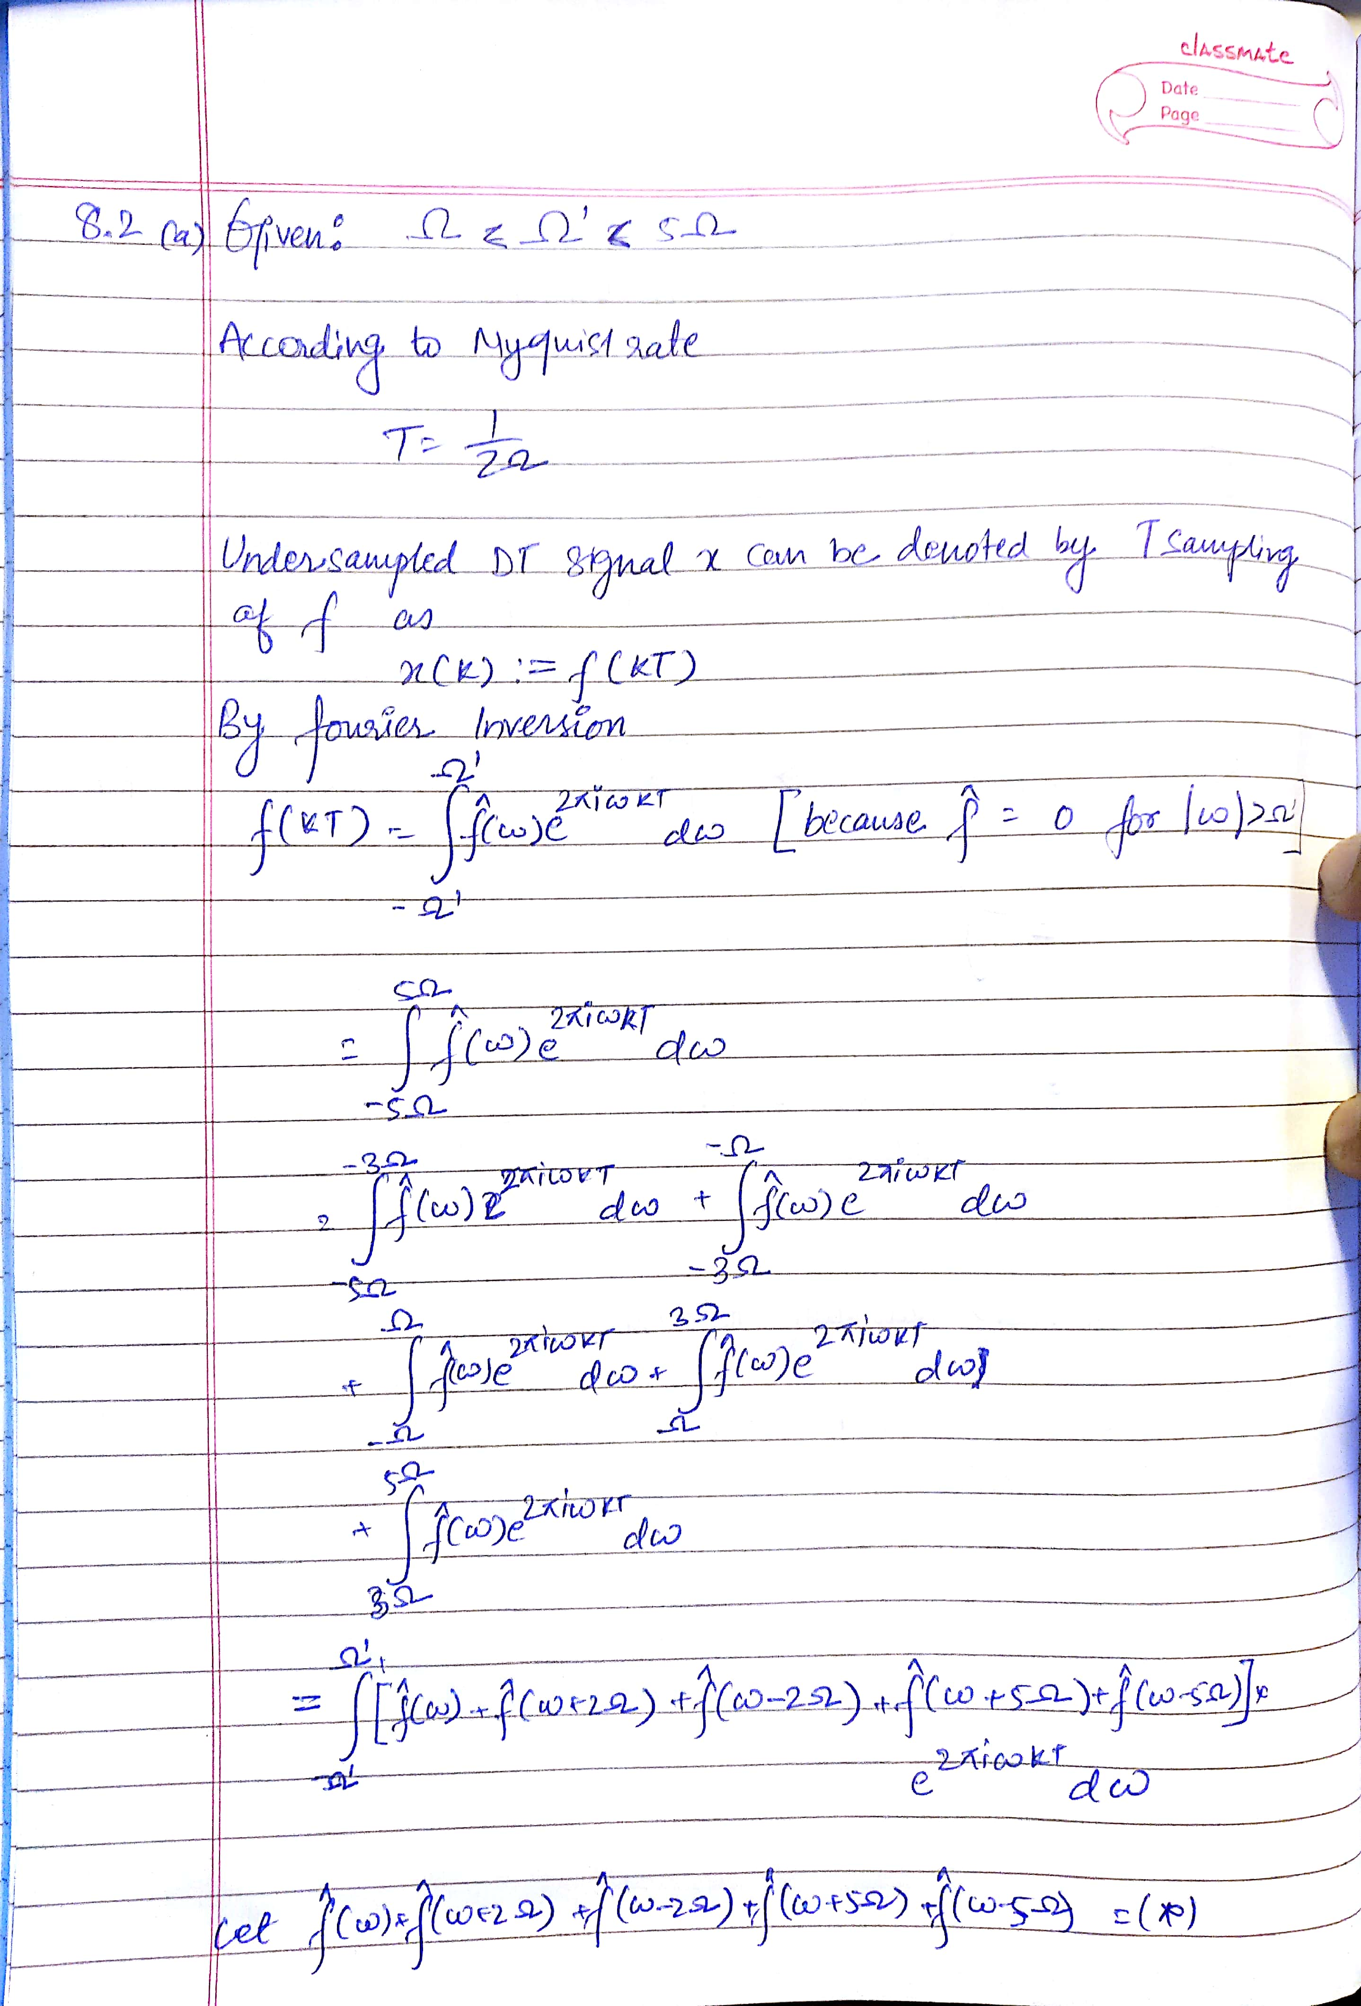



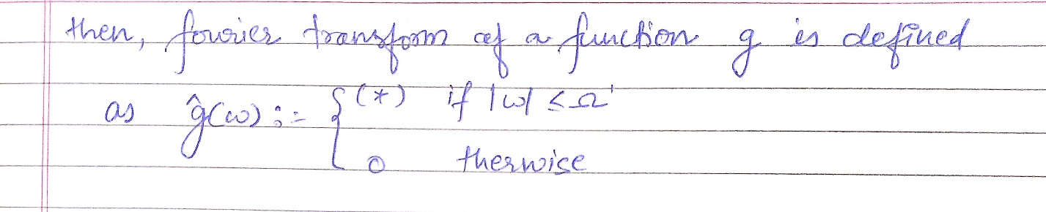



8.2 (b)

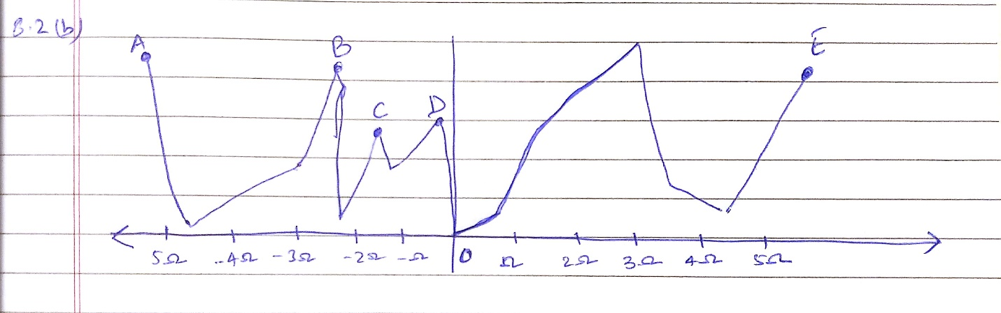



8.3 Plot:



